Media Categorization App:

-user can create, comment on,  categorize, and view an image.

-user can create new image in Db by linking to external site like sharepoint or publicly hosted site

-user can describe and categorize those images

Index:

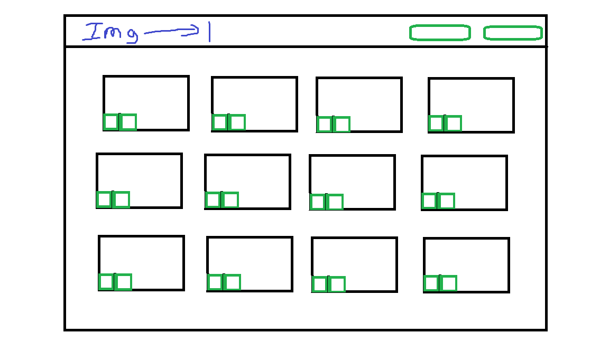

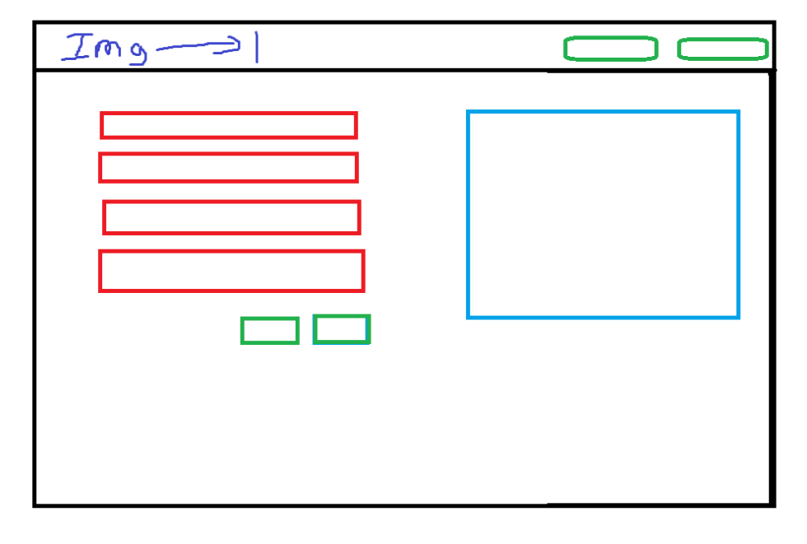New:

Edit:

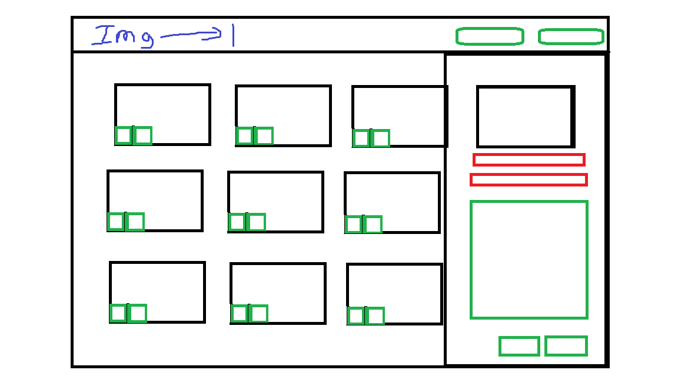

GET /media, /:id, /:id/edit  - get info for editing and showing

POST / media      - create new

PATCH /media/:id  -update existing

DELETE /media    -delete

mediaSchema = {

    fileName: {String, required}

    Category: String,

    Description: String,

}

stretch goals:

allow users to upload images.

user logins

User Priveledges to delete/edit

allow users to upload csv with corresponding filenames to seed en masse

do an array of tags

add search

add filtering

add image recognition API

integrate image recognition into the tags

add video playback/upload

allow user to save comments/tags/categorize mulitple time codes, while not interrupting the video playback.

allow user to navigate time codes they've created while streaming video to amend previous entry

allow users to create lists that allow them to add video/image to that list and view in one place.

allow for 360 video support